Template for Evidence(s)
UI GreenMetric Questionnaire

University : ...
Country : ...
Web Address : …
SAMPLE
[4] Water (WR)

[4.7] Impact of Water Management programs in supporting the Sustainable Development Goals (SDGs)

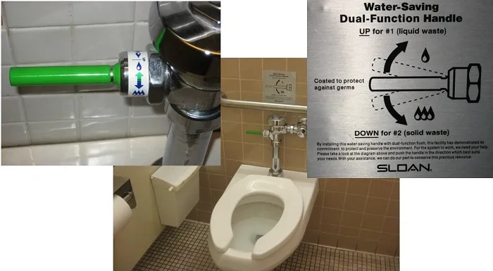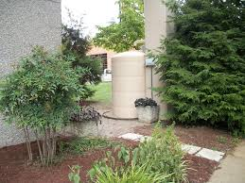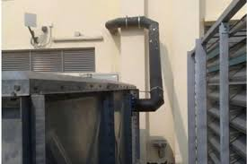
Example

Description:
(Please describe Impact of Water Management programs in supporting the Sustainable Development Goals. You can describe more related items if needed.)
The university has undertaken a wide range of water management programs that contribute significantly to the achievement of the 17 Sustainable Development Goals (SDGs). These initiatives reflect a strong institutional commitment to water conservation, sustainable usage, and climate resilience. Key programs include:
- Installation of rainwater harvesting systems on rooftops and open areas to collect and store rainwater for non-potable uses such as irrigation and toilet flushing.
- Construction of infiltration wells and bio-retention systems to reduce surface runoff and improve groundwater recharge.
- Use of water-saving fixtures (low-flow faucets, dual flush toilets, waterless urinals) across campus buildings to minimize daily water consumption.
- Installation of water meters and digital monitoring systems to track water usage and detect leaks in real time.
- Integration of native and drought-tolerant plant species in landscaping to reduce irrigation demands.
- Implementation of wastewater treatment systems for greywater reuse in flushing, gardening, and cleaning.
- Design of permeable pavements and green roofs to reduce runoff and enhance natural absorption.
- Awareness campaigns and workshops promoting water conservation habits among students, staff, and faculty.
- Inclusion of water-sensitive design principles in new campus developments and renovations.
- Collaborative water management research and policy development in partnership with public agencies, NGOs, and academic institutions.
These efforts directly support SDGs 3, 4, 6, 9, 11, 12, 13, 14, 15, and 17, and contribute indirectly to others, including:
- SDG 3 – Supporting public health through access to clean and safe water
- SDG 4 – Providing learning environments with reliable and sustainable water infrastructure
- SDG 6 – Ensuring availability and sustainable management of water and sanitation for all
- SDG 9 – Implementing innovative water management infrastructure
- SDG 11 – Enhancing urban resilience through sustainable water practices
- SDG 12 – Encouraging responsible consumption of natural resources
- SDG 13 – Mitigating climate impact through adaptive water strategies
- SDG 14 – Preventing water pollution that impacts aquatic ecosystems
- SDG 15 – Protecting terrestrial ecosystems through integrated water management
- SDG 17 – Strengthening water-related partnerships for sustainable development
Additional evidence link (i.e., for videos, more images, or other files that are not included in this file):

